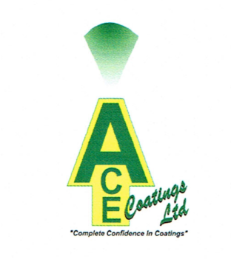

PRODUCT DEFINITION SHEET

PRODUCT NAME: TECHCOAT G4S
CODE: G4S
PRODUCT DESCRIPTION: CONCAST MOULD PAINT

CRITICAL PROPERTIES
SPECIFICATION | SG | 11-15
SOLIDS CONTENT |  | 21-32%

SUPPLEMENTARY PROPERTIES
CHEMICAL ANALYSIS % (DRIED SAMPLE)
 |  | RANGE | TYPICAL
 | CARBON | 17-27% | 22.79
 | Na₂0 | 2% MAX | 0.29
 | SiO₂ | 6% MAX | 3.49
 | Al₂0₃ | 2% MAX | 1.38
 | H₂0 | 68-79% | 72%

…………………………………………………..

For and on Behalf of Ace Coatings Ltd
